Design and implementation of a secure network for Student441 Ltd
Braydan Newman

Data asset inventory

Name | Storage location | Security classification | Security goals (C/I/A)
Customer Data | Database Server | High | C, I
Internal policies | Wiki | Medium | C
Source code | Git Repo Server | Medium | C, I
HR and payroll information | Staff Computers | High | C, I, A
Firewall configurations | All VM’s in nftable config files | Low | I
VPN Server Keys | VPN server (External Router) | High | C
VPN Staff Keys | Staff computers | High | C
Docker images | External server hosting images and on servers running the images | Low | A
Docker compose configs | VM’s running docker services | Low | A
DNS config | DNS server | Low | I

Compute asset inventory
Name | Services | Networks | IP addresses
extrouter | Ssh, Wireguard | Vboxnet0  Vboxnet1  intnet0  intnet100 | 172.0.0.2  172.1.0.1  172.1.100.1
introuter1 | ssh | Vboxnet0  intnet100  intnet1 | 172.1.100.2  172.1.1.1
introuter2 | ssh | Vboxnet0  intnet100  intnet2 | 172.1.100.3  172.1.2.1
introuter3 | ssh | Vboxnet0  intnet100  intnet3 | 172.1.100.4  172.1.3.1
introuter4 | ssh | Vboxnet0  intnet100  intnet4 | 172.1.100.5  172.1.4.1
www | http, ssh | Vboxnet0  intnet0 | 172.1.0.10
db | Mysql, ssh | Vboxnet0 | 172.1.1.11
git | http, ssh, git | Vboxnet0 | 172.1.2.9
wiki | Http, ssh | Vboxnet0 | 172.1.3.12
bastion | ssh | Vboxnet0  intnet0 | 172.1.0.14
dns | Dns, ssh | Vboxnet0  intnet0 | 172.1.0.7

Trust zones

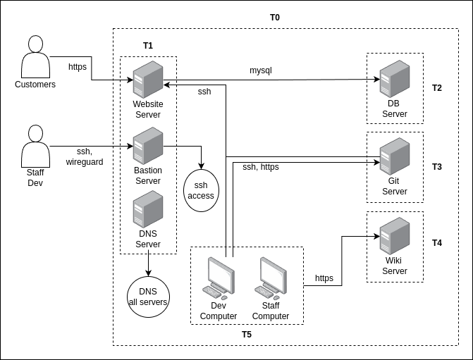
- Trust Zone 0 (T0)
  - This trust zone encompasses the entirety of the network and shows everything in this zone is inherently trusted a minimal amount due to it being run by CabCo. To get to this zone a basic firewall would be setup, mostly to direct traffic, and segregate areas of the network.
- Trust Zone 1 (T1)
  - This trust zone encompasses the edge network (DMZ), these services have to talk directly to customers and the internet. Having to deal with internet traffic that is far less filtered than other services is why these VM’s are all places on the same zone, as they all require less strict network filtering.
- Trust Zone 2(T2)
  - This trust zone has only the DB service in it, this is because the db had specific requirements that no other services had like being able to have connections from the web server. This was also due to the security classification being high, where segregation from less crucial services is recommended.
- Trust Zone 3 (T3)
  - This trust zone has only the Git services in it, this is because the git service has specific requirements that no other services has like need to be able to connect to the web server and update the website. This service would also be getting far more traffic, from Develops, and with its security being medium it should be segregated and put in a separate trust zone.
- Trust zone 4 (T4)
  - This trust zone has only the Internal Wiki service in it, this is because the Wiki has specific requirements that no other services has, it was not put into the T0 as this website can not be accessible from the internet, and has to be accessed by some internally.
- Trust zone 5 (T5)
  - This trust zone holds all the developers and staff computers. This trust zone combines both staff and developers as both have very similar access requirements, with only devs getting a bit more access. These staff computers would also have HR and payroll information on them, this is highly sensitive data and needs to be in a highly trusted zone.

Security controls

Network segmentation
- Reducing Attack Surface
  - By isolating network segments, network segmentation reduces the attack surface available to malicious actors.
- Enforcing the Principle of Least Privilege
  - Network segmentation helps enforce the principle of least privilege, where users, applications, and devices are only given the minimum level of access they need.
- Zero Trust Architecture
  - Segmentation aligns with Zero Trust principles, where no entity inside or outside the network is trusted by default.

Firewalls
- Controlling Access and Traffic Filtering
  - Firewalls enforce policies that define which traffic is allowed to enter or exit a network. By filtering traffic based on criteria such as IP addresses, port numbers, and protocols, firewalls prevent unauthorized access to internal systems and services, blocking potentially malicious traffic while allowing legitimate traffic through.

SSH Bastion
- Centralized Access Control
  - An SSH Bastion centralizes access to sensitive internal resources by acting as a gatekeeper.
- Enforcing the Principle of Least Privilege
  - The SSH Bastion allows for the enforcement of the principle of least privilege by limiting direct access to sensitive systems.
- Minimizing Attack Surface
  - The SSH Bastion acts as a single point of access for SSH connections, reducing the number of externally accessible entry points to sensitive internal systems.
- Supporting Zero Trust Architecture
  - The SSH Bastion aligns with Zero Trust principles by limiting access based on user identity and trust level, regardless of whether the user is inside or outside the organization’s perimeter.

Virtual Private Network
- Data Confidentiality and Integrity
  - VPNs ensure the confidentiality and integrity of data transmitted between remote users and internal networks by encrypting traffic.

Executive summary
- Hard-Coded VPN Keys: Virtual Private Networks (VPNs) help protect data traveling across the internet by encrypting it. When VPN keys (which act like passwords) are hard-coded into the system, they are difficult to update or change. If these keys become compromised (for example, if someone unauthorized gets access to them), it’s very hard to update or fix the problem, leaving the network vulnerable to attack.
- Outdated Software: Software needs to be regularly updated to fix security holes, add features, and improve performance. When a system is running outdated software, it is more vulnerable to hackers, malware, and other security threats. Old software often has known flaws that attackers can easily exploit.
- No Scaling: Scalability refers to a network's ability to grow and handle more users, devices, or data traffic. If a system isn’t built to scale, it can become overloaded when demand increases. This leads to slower performance, disruptions, and downtime.
- No Redundancy: Redundancy in networking means having backup systems in place to take over if the primary systems fail. Without redundancy, if something goes wrong—like a server crashing or a power outage—the entire network could go down, leading to significant downtime and loss of productivity.

Complementary Controls to Address the Risks
- Use Dynamic VPN Keys: Instead of hard-coding VPN keys, dynamic keys can be implemented. These keys change regularly and are easier to update if compromised. Multi-factor authentication (MFA) can also be added to further secure VPN access by requiring users to provide more than just a password, like a code sent to their phone.
- Regular Software Updates: Implement a patch management system to regularly update software across the network. This will close security gaps and ensure that the system benefits from the latest improvements. Automatic updates can also help reduce the burden on IT staff.
- Design for Scalability: Build the network with the future in mind. Cloud services and scalable infrastructure allow the network to grow as the organization expands. By adding capacity dynamically (as needed), you avoid overloads during high-traffic periods and ensure that the system performs efficiently as demand grows.
- Implement Redundancy: Add redundant systems such as backup servers, power supplies, and network connections. If one system fails, another will immediately take over, preventing downtime. Load balancing can also be used to distribute network traffic evenly across multiple servers, reducing the risk of a single point of failure.

